How to care for your removable appliance or nightguard

General Instructions:
- Wear appliance as recommended
- After removing your appliance, clean it with toothpaste and a toothbrush. (Soap and water will also work!)
- Rinse under warm tap water
- When not wearing appliance/nightguard, store it in the protective case provided
- Occasionally soak the appliance in a denture cleanser, such as Efferdent, to remove any stubborn stains and or deposits.
- Remember to bring your appliance with you to each dental visit for cleaning and possible adjustments.
- Please avoid squeezing your appliance or nightguard as it may snap in the midsection… see diagram below for further questions.

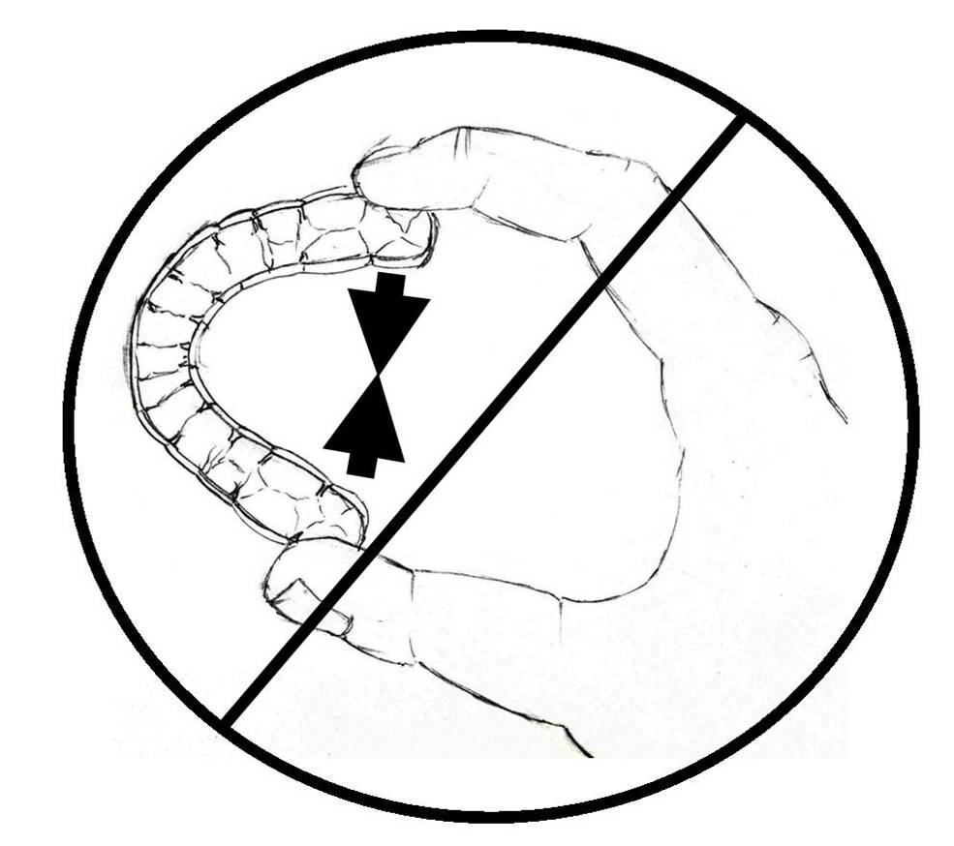
- Please don’t hesitate to call us with any questions or concerns you may have.
- We can be reached at (202-244-4111)

